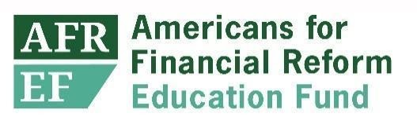

Good Afternoon and thank you for allowing me the opportunity to speak with you today. My name is Elyse Hicks and I am Counsel at Americans for Financial Reform Education Fund . I am also a graduate of the Charleston School of Law; however, I began my law school career at the Charlotte School of law, which was a for-profit institution owned by a private equity firm.

Because of the school’s deceptive recruitment practices, such as the non-disclosure of low bar passage rates and its then pending probation status with the American Bar Association in the fall of 2016, students at every level received notification during Christmas break that the school was no longer eligible for Title IV funding.

According to the latest data, roughly 71% of college and graduate level students rely on title IV funding to complete their studies, and without it I was forced to scramble for spring admission at a new school, in a new city, with nowhere to live during my first week of classes.

Many of my colleagues, who were in their second and third year at the time, had no other recourse than to stay at Charlotte in fear of losing their credits and having to start over. They were struggling to stay in their apartments, and even eat. Professors lost their jobs and those that were left placed peanut butter and jelly in the student lounge for students who were hungry. Some professors even housed students for the semester.

Luckily, I was able to finish law school, in Charleston, a semester early, but now that I am in ***this*** seat I wonder if my path here would have been less turbulent if there were more scrutiny on the certification process of institutions wanting to gain access to Title IV funding. I wonder if there were better safeguards in place would students be taken advantage of in this way?

It is undeniable that NO student should have their right to education stripped away because an institution isn’t providing the services described in its official publications and statements. I respectfully urge the committee to set stricter guidelines when certifying schools that would like to participate in federal funding to protect students from horrible experiences like these, and to use all of the tools at your disposal to increase accountability and end abuses.

Thank you.